**CS825-001, Spring/Summer 2020**

**Assignment 4- Part 1**

**Submitted to Dr. Xue Dong Yang**

**By**

**Adarsh Koppa Manjunath**

**200397257**

**Q1) input image car.raw**

**Output image – magnitude is computed from dft and then it will be scaled. Below image is the final scaled image.**

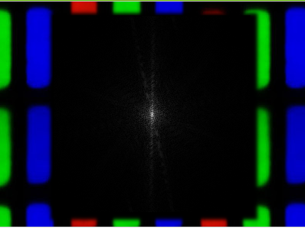

**Fig 1- final scaled image after computing magnitude of dft of car image.**

**Screenshots of computation performed during the execution of program for the car input image**

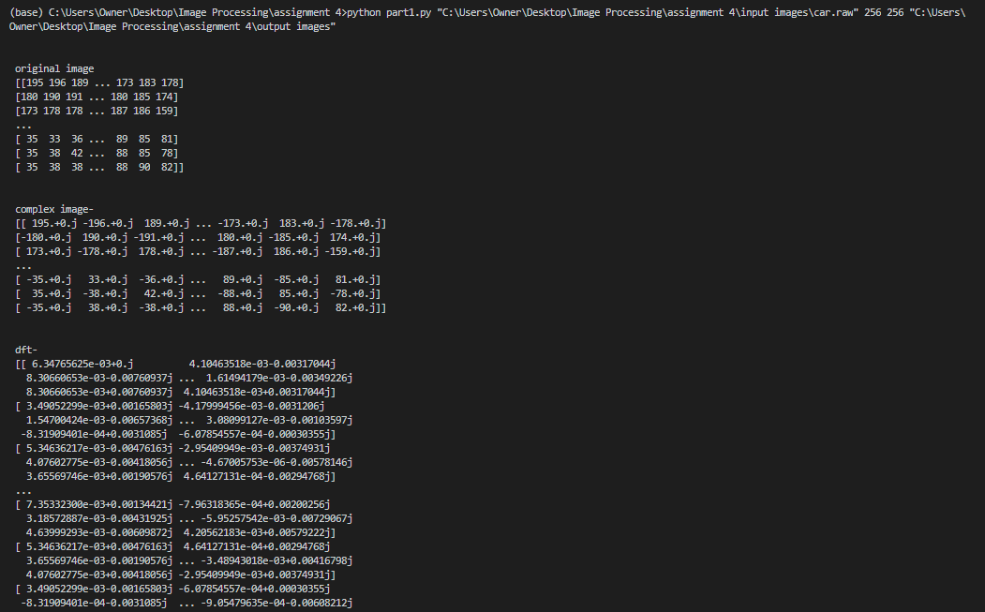

**Fig 2- computation performed with the input car image**

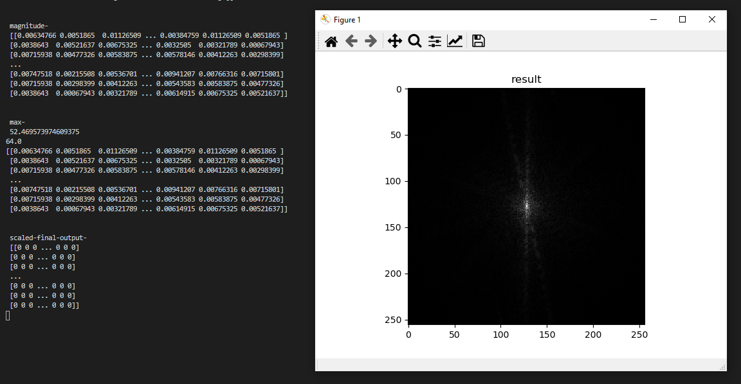

**Fig 3- computation performed with the input car image**

**Q1) input image square256.raw**

**Output image- magnitude is computed from dft and then it will be scaled. Below image is the final scaled image.**

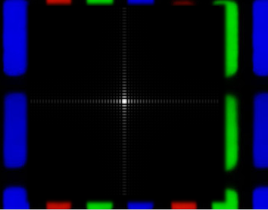

**Fig 4- final scaled image after computing magnitude of dft of square image**

**Screenshots of computation performed during the execution of program for the square input image**

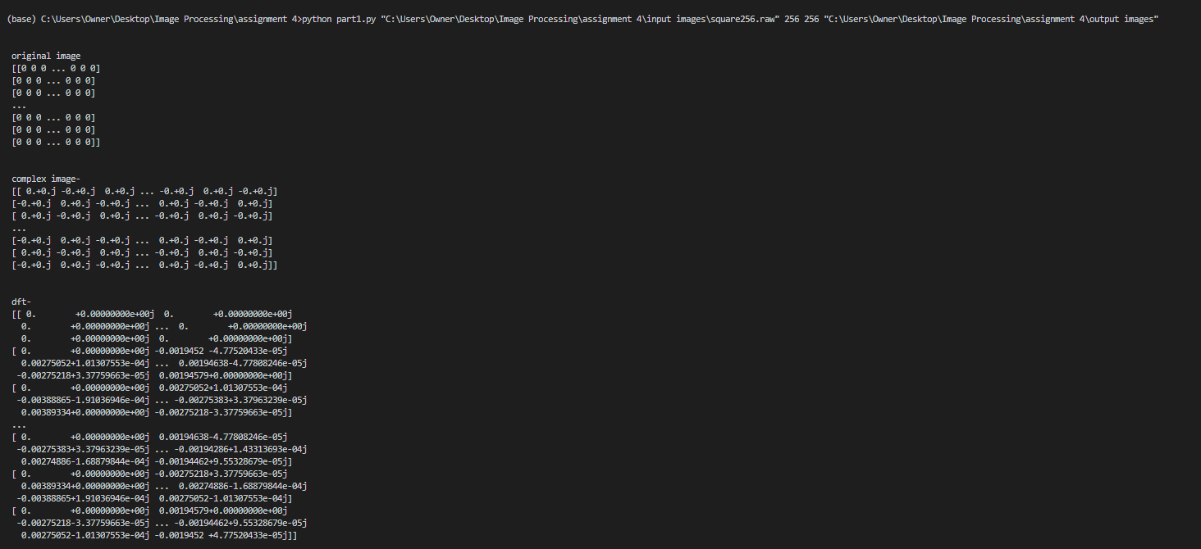

**Fig 5- computation performed with the input square image**

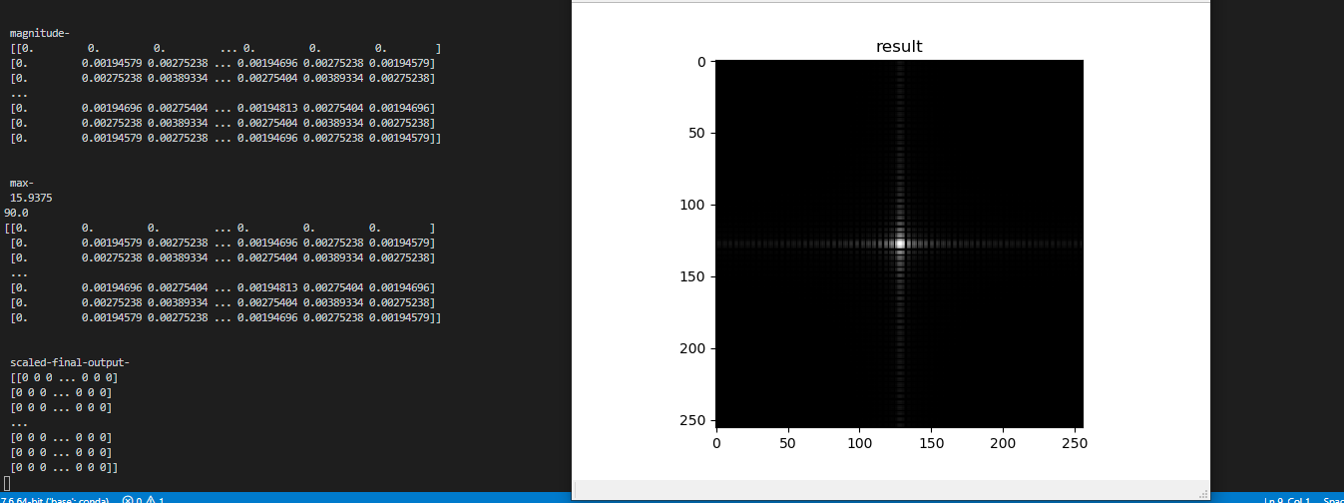

**Fig 6- computation performed with the input square image**